# PROJECT REPORT

## On

**Chandigarh Tourism Website**

## COMPUTER APPLICATIONS

**BCA Batch-2018 in**

**DECEMBER-2020**



|  |  |
| --- | --- |
| **Under the Guidance of:** | **Submitted By:** |
| **Mr. Shankar S Aggarwal** | **Rohan Mondal** |
|  | **Id. No. 1813987016** |
|  | **Harish Chandra** |
|  | **Id. No. 1813986009** |
|  | **Saurabh Banga** |
|  | **Id. No. 1813986020** |
|  | **Shashank Sahdev** |
|  | **Id. No. 1813987020** |

**DEPARTMENT OF COMPUTER APPLICATIONS**

**CHITKARA UNIVERSITY**

**HIMACHAL PRADESH**

**CERTIFICATE**

This is to be certified that the project entitled “Chandigarh Tourism Website” has been submitted for the Bachelor of Computer Applications at Chitkara University, Himachal Pradesh during the academic year July 2020-December 2020 is a bona fide piece of project work carried out by “Name-Shashank Sahdev , ID-1813987020 , Name-Rohan Mondal , ID-1813987016 , Name-Harish Chander , ID-1813986009 , Name Saurabh Banga , ID-1813986020” towards the partial fulfillment for the award of the course Major Project (CA133) under the guidance of **“Mr.** **Shankar S Aggarwal''** and supervision.

### Signature of Project Guide

Mr. Shankar S Aggarwal

(Assistant Professor at Chitkara School of Computer Application)

**CANDIDATE’S DECLARATION**

We, Shashank Sahdev , ID-1813987020 , Rohan Mondal , ID-1813987016 ,Harish Chander , ID-1813986009 ,Saurabh Banga , ID-1813986020 GROUP - 6**, BCA**-2018 of the Chitkara University, Himachal Pradesh hereby declare that the “major project” Report entitled **“Chandigarh** **Tourism ”** is an original work and data provided in the study is authentic to the best of our knowledge. This report has not been submitted to any other Institute for the award of any other course.

|  |  |  |  |
| --- | --- | --- | --- |
| **Sign. of Student 1** | **Sign. of Student 2** | **Sign. of Student 3** | **Sign. of Student 4** |
|  |  |  |  |
| Shashank Sahdev | Saurabh Banga | Rohan Mondal | Harish Chander |
|  |  |  |  |
| ID-1813987020 | ID-1813986020 | ID-1813987016 | ID-1813986009 |
|  |  |  |  |

**ACKNOWLEDGEMENT**

It is our pleasure to be indebted to various people, who directly or indirectly contributed in the development of this work and who influenced our thinking, behavior and acts during the course of study.

We express our sincere gratitude to all for providing an opportunity to undergo “Digital marketing”- Project as the part of the curriculum.

We extend our sincere appreciation to ***“Mr.Shankar*** S Aggarwal”who provided his valuable suggestions and precious time in accomplishing our project report.

Lastly, we would like to thank the almighty and our parents for their moral support and friends with whom we shared our day-to-day experience and received lots of suggestions that improve our quality of work.

**TABLE OF CONTENT**

**Introduction 6**

**Purpose** **8**

**Modules** **8**

**Users:** **8**

**Hardware Requirements for User:** **9**

**Software Requirement for Use:** **9**

**Advantages:** **9**

**Disadvantages:** **9**

**OVERALL DESCRIPTION** **10**

**For Administrators** **10**

**6.0. Integrating the Website and Database** **21**

**8.0. Project Design** **23**

**9.0. Functional Decomposition Diagram** **24**

**Data Flow Diagram (DFD)** **25**

**Limitations and Future Development** **30**

**11.0. Input & Output Snapshots** **31**

**13.0. Conclusion** **46**

* 1. **Introduction**

Chandigarh Tourism is a very user friendly project. In this project users can easily understand and book all packages and also register for hotels. In this project there are various types of forms, like all types of packages, book for package and Room Registration Page in which the user can insert his personal needs & facilities then upload his form by which user can register in the web site. In this website users can also pay money through Wallet.

This site provides different tour packages for Chandigarh, hotel booking and summer special tour packages. Through this site, users can book different types of rooms such as deluxe rooms, ac rooms etc at a flexible price.

This site provides different packages for and hotel booking services in one particular city Chandigarh. Rose garden is a very popular hill station of Chandigarh. Visitors enjoy snow covered mountain peaks and adventure sports like trekking, mountaineering and skiing.

In this website, according to the tour packages it provides services like online booking facilities for all packages and hotels registration to the customer. In this project users can easily understand and fill up the Room Reservation form. Users can search for various types of rooms.

Chandigarh Tourism is a web based application made in Asp.Net. So with the help of this project users can apply for packages of tour and room reservation.

The software has the following three main components:-

* + 1. Implement new users to register and login.
    2. Implement the user to choose any locations in Chandigarh.
    3. Implement the user to book tickets.

The website will be implemented using PHP as the programming language. MYSQL database will be used to link databases.

**Abstract**

The recent past showed a greater interest in recommender techniques. Now-adays there are many Chandigarh travelling packages existing from different websites. A customer finds it very difficult to search for the best package as he has to browse multiple websites, contact many travelling agents and etc. which is a tedious process and is time consuming. There should be a system where the user should find the best package on the Internet with a single click. To address this issue, we adopt the Chandigarh Tourism which offers the best package among all the other packages that are on the web. This project will help tourists to suggest the best Chandigarh Travelling Packages among all the packages deals on the web. On multiple demands of tourists, that is, a customer will select a travel package for a particular place based on the recommendations provided by the previous customers who had experience with the package. Therefore, according to the personalized recommendations, he will choose the best Chandigarh Trip package that is on the web. Initially, we will evaluate the particular characteristics of the current traveling packages and we mine the data on the tourists rating and the intrinsic features i.e., locations, travel seasons etc. Based on the data collected after mining, we will generate a list for personalized travel package recommendations. Furthermore, we will extract the data based on the tourist's relation with the area and season.

# Purpose

For the project, we propose to build an online Chandigarh Tourism Website for People. The online Chandigarh Tourism Website will contain Travelling, Flight Booking, and Hotels. Many people find so many good places like Sukhna Lake, Rose Garden, and Rock Garden. By the help of our website, users can book tickets very easily by his/her smart phone. Our website is easy to use.

# Modules

The site will contain the following features:

* Registration / Login
* Chose Hotel
* Chose Flight
* Chose Train
* Chose Bus
* Chose Car/Cab
* Website Wallet
* Payment option

# Users:

Register - The user needs to be registered in order to login. Login - The users need to login in to get access to the system.

View Order - Here the user can view book tickets and its details.

Search –The user can search places by name after which the system will evaluate flight, train, bus details to give the user the best search result.

# Hardware Requirements for User:

* Processor – I3
* Hard Disk – 50GB
* Memory – 1GB RAM
* Monitor

# Software Requirement for Use:

* Windows 7 or higher
* XAMPP control panel
* MySQL
* Chrome (Updated version) or Any Browser

# Advantages:

# ·The Chandigarh Tourism Packages will be presented based on the interest of the tourist.

# ·By using tourist, area and season as our inputs we can represent our travel data in the best form.

# ·By using this recommendation approach the flaws of the existing system will be eliminated as it performs much better than traditional techniques.

* The algorithm ‘Weighted Average Entropy’ will help the tourist to find the best package in the particular area based on season and theme.

# Disadvantages:

* Travel data is much fewer and sparser than traditional items.
* The traditional items for recommendation usually have a long period of stable value, while the values of travel packages can easily depreciate over time.
* The real world travel recommendation systems are usually very complicated.
* Every travel package consists of many landscapes (places of interest and attractions), and thus has an intrinsic complex spatial temporal relationship.

# OVERALL DESCRIPTION

This project designs an online Chandigarh Tourism provides a web-based interface. It is the graphical user interface. It has a form for users to input query information to search the database. The user interface then passes the input to the control function, which is implemented in php. The control function is designed to process the input from the users interface, generate the searching query and then gets data from the database and returns to the users interface. The control functions also have bridges to search some external real online Chandigarh Tourism.

# For Administrators

* + - Taking backup of the Database .
    - Editing / Deleting / Creating the database .
    - Changing the password .

**Use Cases:**

**Browse Catalog**

1. **Search for a hotel**
   * **Purpose**: A user can search for a hotel of his choice by selecting hotel name or place name. Then a select query is used to retrieve data from the database and display the selected information.
   * **Actor:** User
   * **Input:** The user will select a category and enter the name in a search box provided.
   * **Output:** The system will display the hotels, which matches the selected search criteria. A dataset is created as a result of a select query. Later the dataset is binded to the data repeater to display the selected data.
2. **Perform Advanced feature**
   * **Purpose**: If the user wants to perform an advanced feature he can go for any of the options given in the home page of his choice by selecting place, date and price range. Then a select query is used to retrieve data from the database and display the selected information.
   * **Actor:** User
   * **Input:** The user will select a flight,place,date, and price range in a box provided.
   * **Output:** The system will display the flights, hotel names which match the selected search of the user. A dataset is created as a result of a select query. Later the dataset is binded to the data repeater to display the selected data.
3. **Give feedback**
   * **Purpose**: If the user wants to give feedback according to his opinion for a book he can select either Excellent, Very good, good, regular or deficient. The final rating of a book will depend on all the individual user feedback.
   * **Actor:** User
   * **Input:** The user will select feedback based on his opinion.
   * **Output:** The system will display the feedback of a book and the total number of votes received.

**Add Blog**

We can add and remove the blogs for our account.We can see the other blogs which were uploaded by the other tourister.

Techknowledge used:- PHP

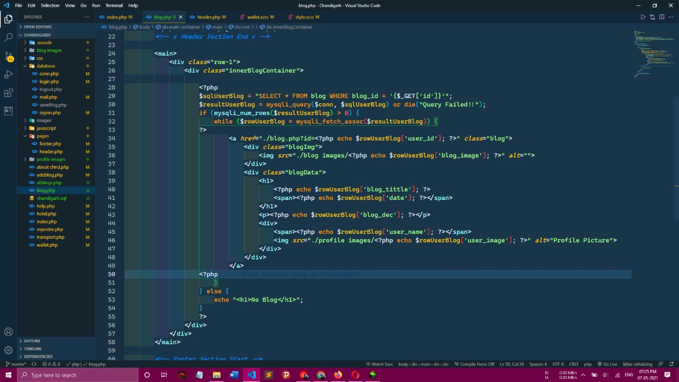

**Maintain Sign-in Account**

**Register**

* + **Purpose**: If the user doesn’t have an account then he will be asked to register.
  + **Actor:** User
  + **Input:** The user will enter details in the registration form according to the required fields. The fields include

1. Username
2. Password
3. confirm password
4. first name
5. last name
6. email
7. Address
8. Phone
   * **Output:** After registration the user will be directed to the main home page.
   * **Technologies:**-PHP

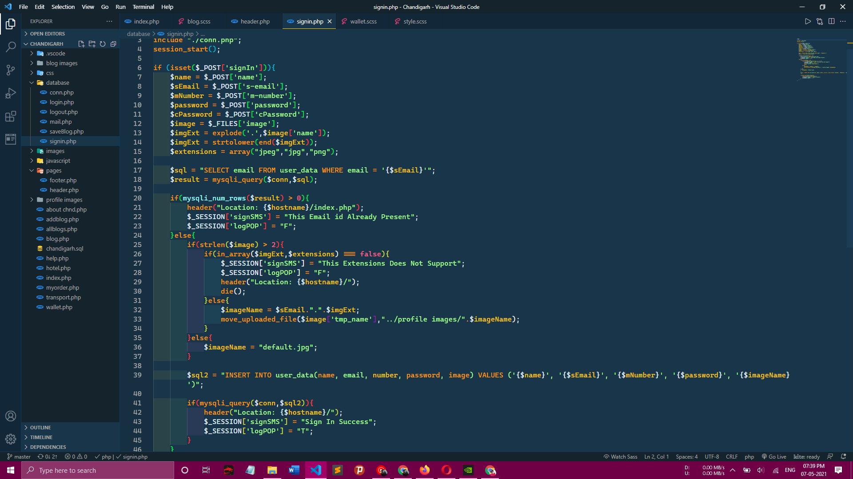

**Login**

* + **Purpose**: If the user wants to book anything e.g. hotels, flights, food etc he should login using his username and password.
  + **Actor:** User
  + **Input:** The user will enter his username and password.
  + **Output:** If it is a successful login the user will be directed to the main home page. Else if the user enters invalid information he will be asked to check the entered information.
  + **Technologies:**-PHP,CSS,JAVASCRIPT,HTML

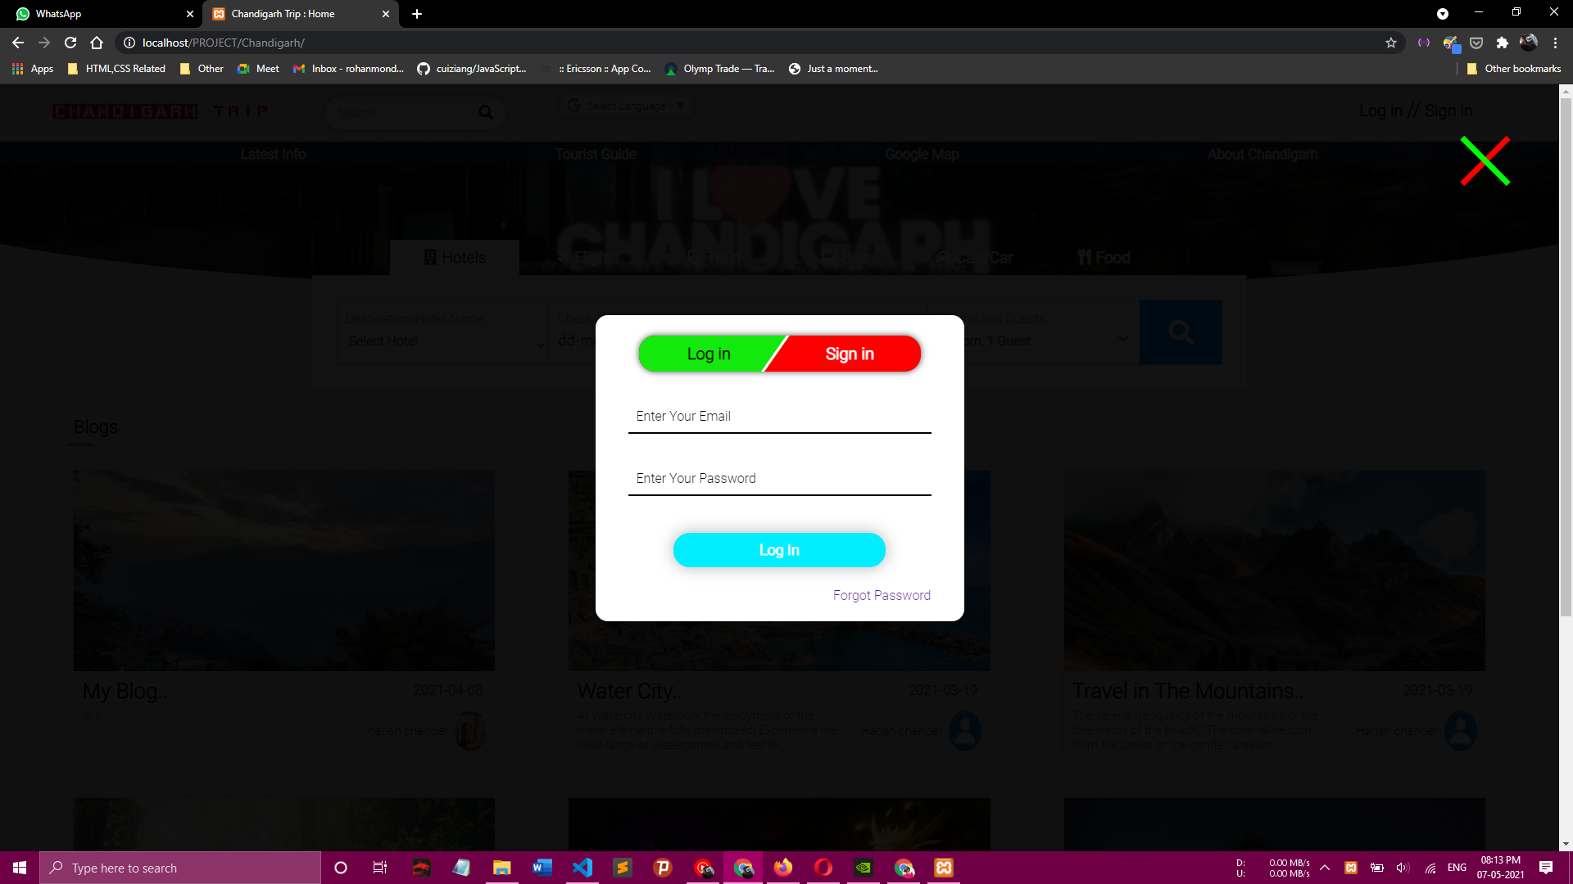

**Logout**

* + **Purpose**: If the user wants to end his session and sign out of the website then he can use the logout option.
  + **Actor:** User
  + **Input:** The user will click the logout button.
  + **Output:** The user’s account session comes to an end and he should login again if he wants to enter into the website.

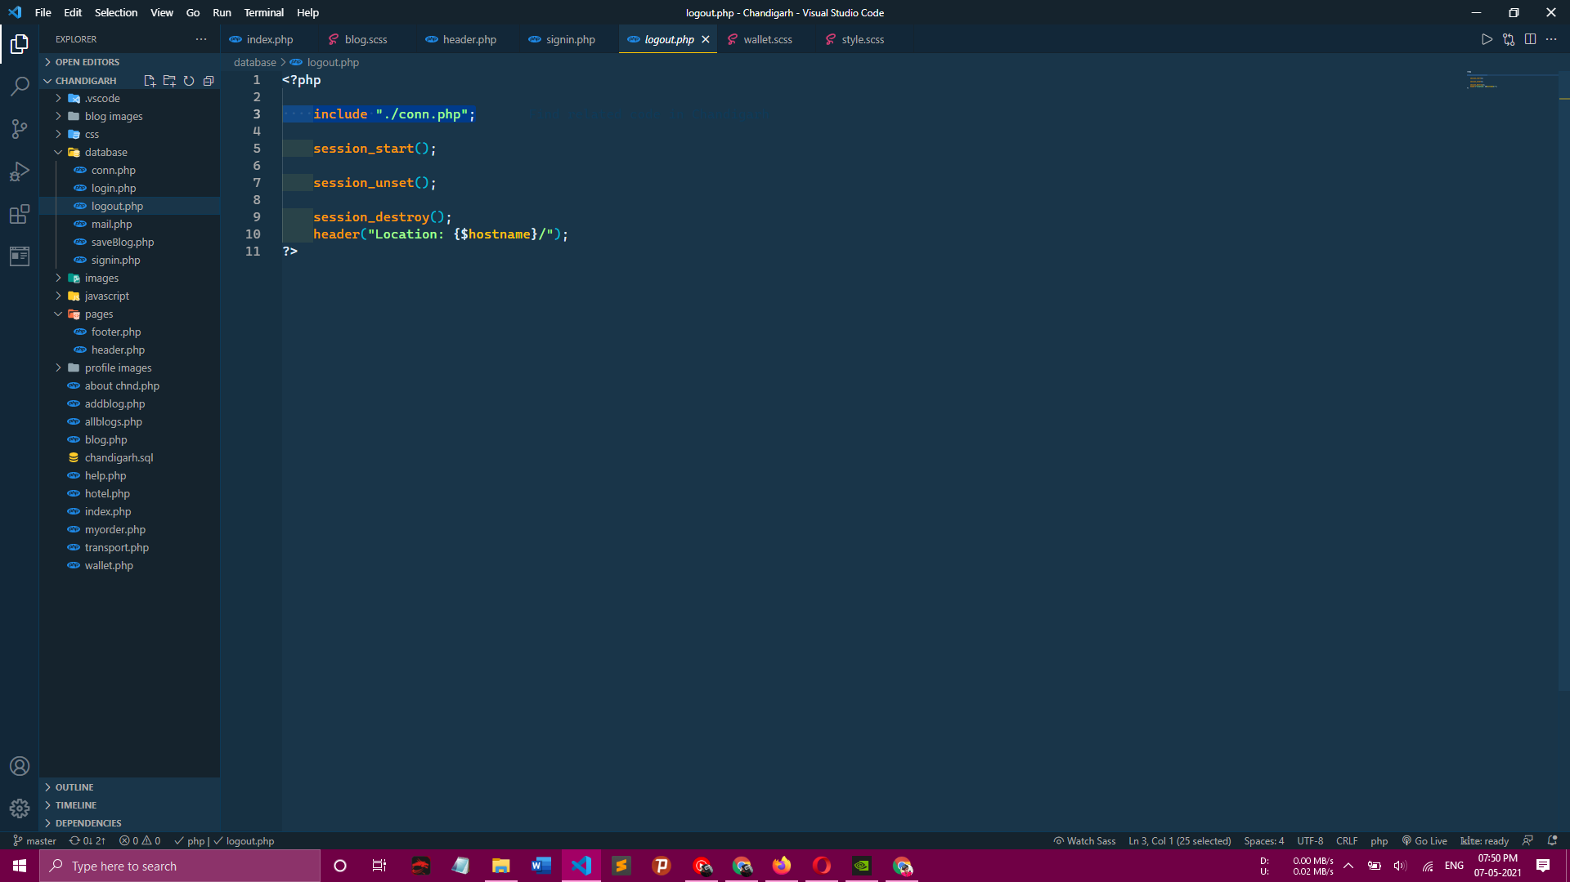

**Manage All Function**

1. **Place an order**
   * **Purpose**: If the user wants to book anything he can go to the home page and book his favourite hotels, food, and flights. All functions will be available on the home page.
   * **Actor:** User
   * **Input:** The user will click on what he wants and then he fills his details.
   * **Output:** The user will get confirmation Mail from our website.

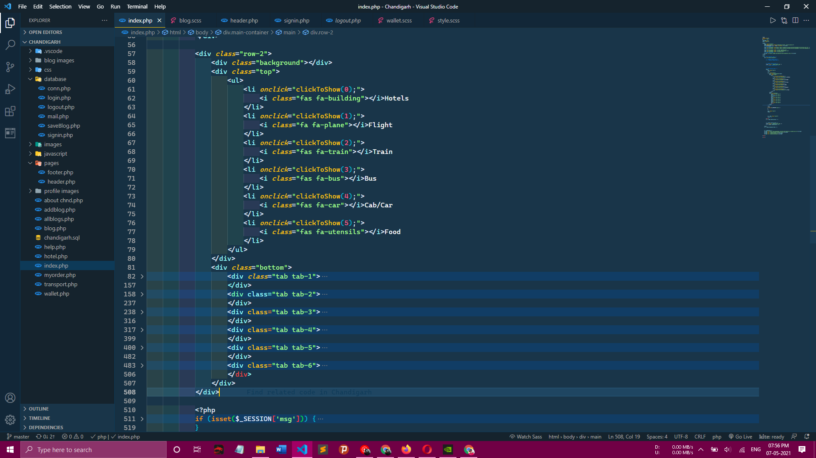

1. **View Order Details**
   * **Purpose**: If the user wants to view the booking he can see his booking details in Gmail which will be sent by our website.
   * **Input:** The user will go in G-Mail apk and then he will see.
   * **Output:** The user will see a Mail in which he will see all details.

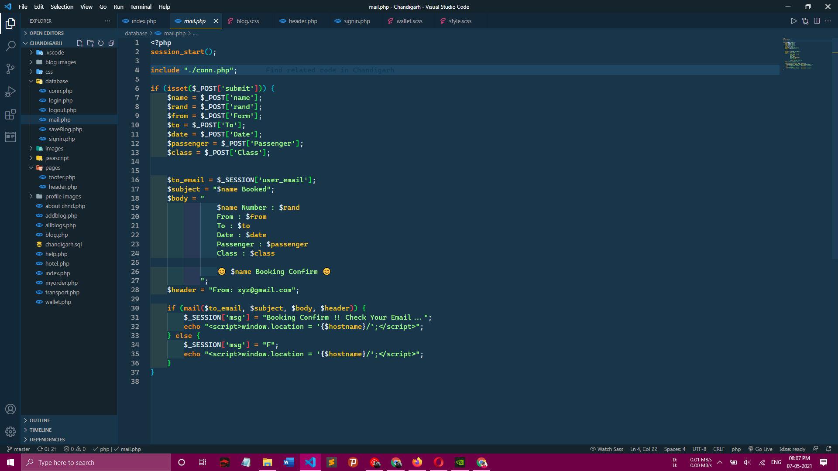

**Administrator**

1. **Login**
   * **Purpose**: If the Administrator wants to get access to all the functionalities of Online Book Store he should login using his username and password.
   * **Actor:** Administrator
   * **Input:** The Administrator will enter his username and password.
   * **Output:** If it is a successful login the Administrator will be directed to his menu page. Else if the Administrator enters invalid information he will be asked to check the entered information.

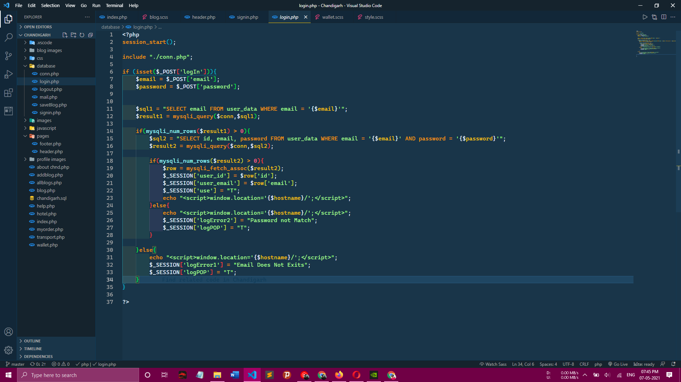

**Add or Delete Profile, Blogs**

* + **Purpose**: If the Administrator wants to add or delete a Profile,Blogs then he can insert or delete a Profile, Blogs using his administration rights and the result will be updated in the database table.
  + **Actor:** Administrator
  + **Input:** If the Administrator wants to add a Blogs then he should click the insert link button in the Blog page and fill the following fields related to the Blogs.

1. Title
2. Images
3. Details
4. Comments

If he wants to delete a Profile he can click the delete button to remove it from the database.

* + **Output:** The updated Profile will be deleted from the database.

1. **Manage Orders**
   * **Purpose**: If the Administrator wants to add or delete an order then he can insert or delete an order using his administration rights.
   * **Actor:** Administrator
   * **Input:** If the Administrator wants to add an order then he should click the insert link button in the orders page else he can delete a particular selected order
   * **Output:** The updated orders list will be processed to the users
2. **Add Money in Wallet**
   * **Purpose**: If he wants to book anything from our website then he needs to add Money in wallet.
   * **Actor:** User
   * **Input:** He needs to insert his card details to add money in the wallet.
   * **Output:** The wallet will update with money he adds in the wallet throw his card.
3. **Add or Delete Order**
   * **Purpose**: If the Administrator wants to add or delete an order then he can insert or delete an order using his administration rights and the category table will be updated in the database.
   * **Actor:** Administrator
   * **Input:** If the Administrator wants to add an order then he should click the insert link button in the category page else he can delete a particular selected order.
   * **Output:** The updated categories list will be displayed in the main home page.
4. **Logout**
   * **Purpose**: If the Administrator wants to end his session and sign out of the website then he can use the logout option.
   * **Actor:** Administrator
   * **Input:** The Administrator will click the logout button.
   * **Output:** The Administrator’s account session comes to an end and he should login again if he wants to enter into the website.
   1. **Environment**
      * Chandigarh Tourism website will be developed in the Programming language platform
      * Techknowledge: Java, css, JavaScript, html will be used as the programming language.

# 6.0. Integrating the Website and Database

Customers ordering from an e-commerce website need to be able to get information about a vendor’s products and services, ask questions, select items they wish to purchase, and submit payment information. Vendors need to be able to track customer inquiries and preferences and process their orders. So a well-organized database is essential for the development and maintenance of an e- commerce site. In a static Web page, content is determined at the time when the page is created. As users access a static page, the page always displays the same information. Example of a static Web page is the page displaying company information. In a dynamic Web page, content varies based on user input and data received from external sources. We use the term “data-based Web pages” to refer to dynamic Web pages deriving some or all of their content from data files or databases. A data-based Web page is requested when a user clicks a hyperlink or the submit button on a Web page form. If the request comes from clicking a hyperlink, the link specifies either a Web server program or a Web page that calls a Web server program. In some cases, the program performs a static query, such as “Display all items from the Inventory”. Although this query requires no user input, the results vary depending on when the query is made. If the request is generated when the user clicks a form’s submit button, instead of a hyperlink, the Web server program typically uses the form inputs to create a query. For example, the user might select five books to be purchased and then submit the input to the Web server program. The Web server program then services the order, generating a dynamic Web page response to confirm the transaction. In either case, the Web server is responsible for formatting the query results by adding HTML tags. The Web server program then sends the program’s output back to the client’s browser .

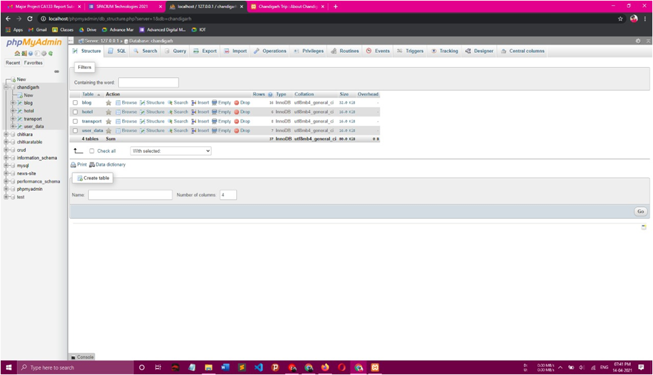

**SYSTEM IMPLEMENTATION**

* The web based application Chandigarh Tourism was implemented in JAVASCRIPT using CSS, PHP, and the database is MySQL. Here are some of the implementation details.
* The Chandigarh Tourism was developed using Programming languages in

Windows 10.

* The web-based application requires access to the Xampp services. The user has to register in the website, in order to access the application. Once the user is registered in the website, the user is allowed to login to the application and will be navigated to the Home screen.

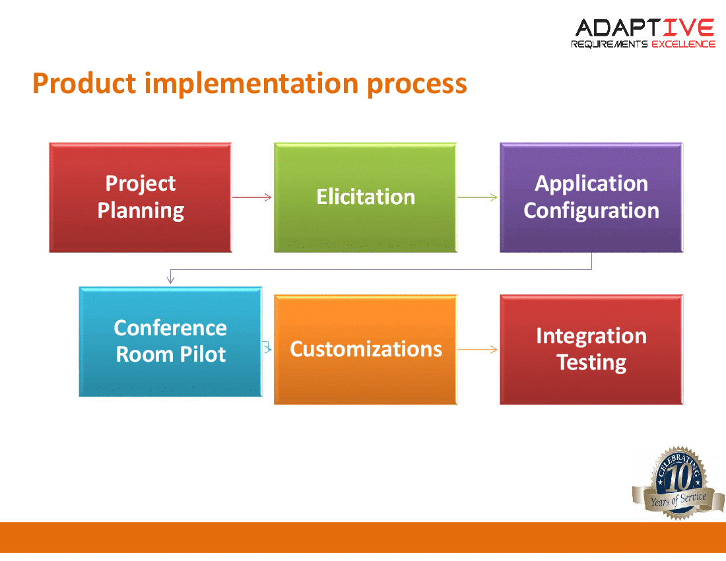

Note: This Fig is taken from google just for understanding.

# 8.0. Project Design

In order to design a web site, the relational database must be designed first. Conceptual design can be divided into two parts: The data model and the process model. The data model focuses on what data should be stored in the database while the process model deals with how the data is processed. To put this in the context of the relational database, the data model is used to design the relational tables.

The process model is used to design the queries that will access and perform operations on those tables.

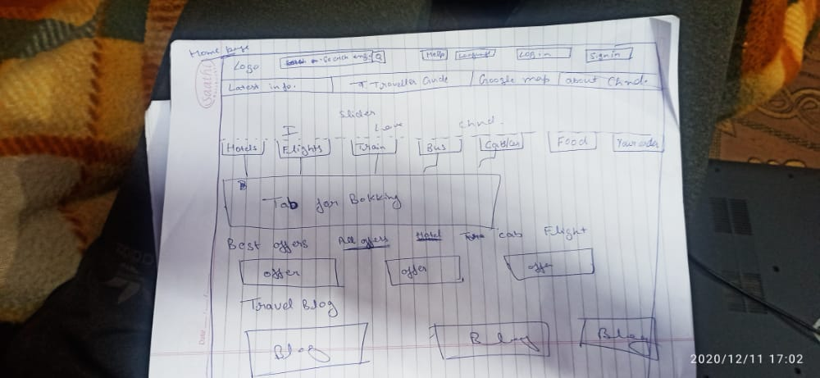

# 9.0. Functional Decomposition Diagram

A decomposition diagram shows a top-down functional decomposition of a system and exposes the system's structure. The objective of the Functional Decomposition is to break down a system step by step, beginning with the main function of a system and continuing with the interim levels down to the level of elementary functions. The diagram is the starting point for more detailed process diagrams. shows the Functional Decomposition Diagram for this project.

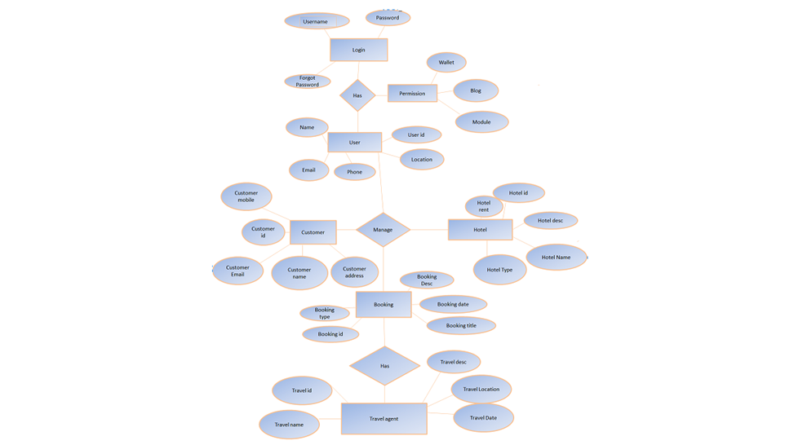

# Data Flow Diagram (DFD)

Data Flow Diagrams show the flow of data from external entities into the system, and from one process to another within the system. There are four symbols for drawing a DFD:

* + 1. Rectangles representing external entities, which are sources or destinations of data.
    2. Ellipses representing processes, which take data as input, validate and process it and output it.
    3. Arrows representing the data flows, which can either, be electronic data or physical items.
    4. Open-ended rectangles or a Disk symbol representing data stores, including electronic stores such as databases or MYsql files and physical stores such as filing cabinets or stacks of paper.

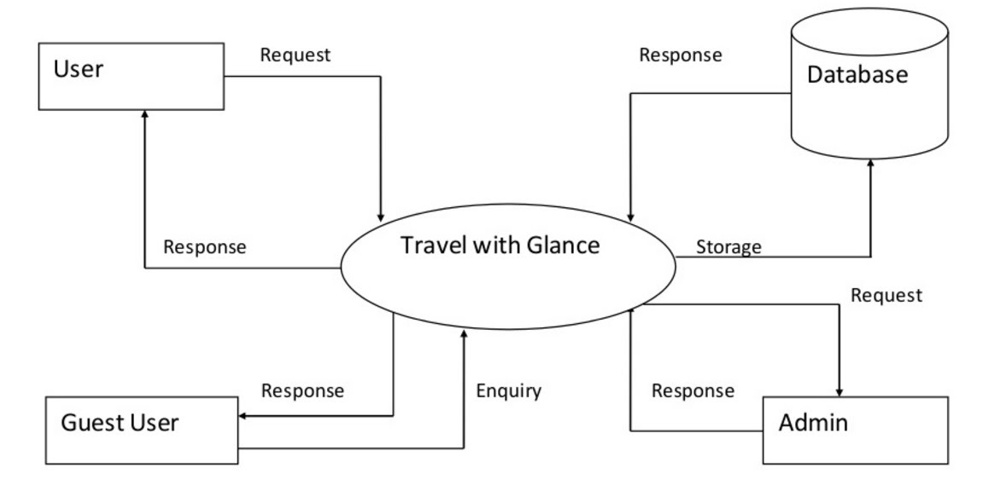

Note: Theasl Fig is taken from google just for understanding.

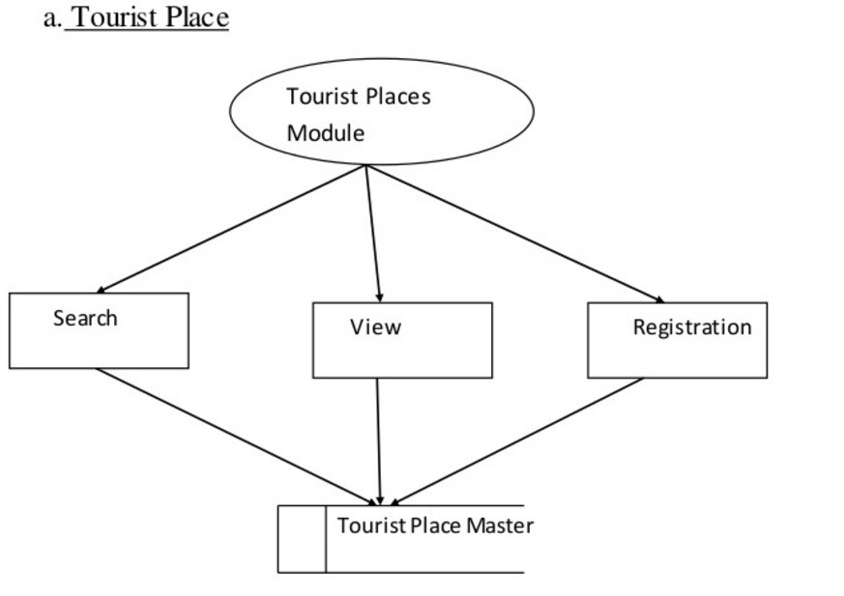

Note: Theasl Fig is taken from google just for understanding.

**SOFTWARE TEST**

|  |  |  |
| --- | --- | --- |
| **Sr.Nos.no** | **Test Case Description** | **Result** |
| 1. | Project name | Chandigarh Tourism |
| 2. | Application Name | Chandigarh Trip |
| 3. | Current Version | 1.0 |
| 4. | Previous Version | NA |
| 5. | Received Date from DataBase | Yes |
| 6. | User Data security | Yes |
| 7. | Verified if user able to book ticket one way / Multiple booking | Yes |
| 8. | Password Security | Yes |
| 9. | Working on Any Browser | Yes |
| 10. | Verify Wallet Transactions | Yes |
| 11. | Customer care support 24*7 | NA |
| 12. | Responsive Website | Yes |
| 13. | ID and Password Required | Yes |
| 14. | Log-outsession | Yes |
| 15. | Order Confirmation mail | Yes |

**Test Case:-**

Test of These Module are:-

a):- Login and Password Validation

|  |  |  |
| --- | --- | --- |
| **Input** | **Unit Of Measure** | **Validation Rules** |
| User ID | Character | Start With alphabet,@,.com |
| Password | Character | contain uppercase,@,$,%,&,_ and Numeric |

**Process:-**

|  |  |  |
| --- | --- | --- |
| **Operation** | **Unit Of Measure** | **Result** |
| Capturing / Records | User Id and Password  are Matched, no field is blank | Login Successful |

**OutPut:-** Login Successful Open Main Screen

B):- Order Booking Detail:-

|  |  |  |
| --- | --- | --- |
| **Input** | **Unit Of Measure** | **Validation Rules** |
| User Name | Character | 26 Character |
| Booking Type | Room/Flight/Food/Cab | Confirm |
| No. of Person | Integer | Integer Type/e.g.:-1,2.. |
| Date | Date | DD/MM/YY |

**Process:-**

|  |  |  |
| --- | --- | --- |
| **Operation** | **Validity Check on Input** | **Data Produce** |
| Capturing / Record input | Check Customer,Booking /Detail in Database | Order Booking Detail , Customer Detail , Date , No. of Person |

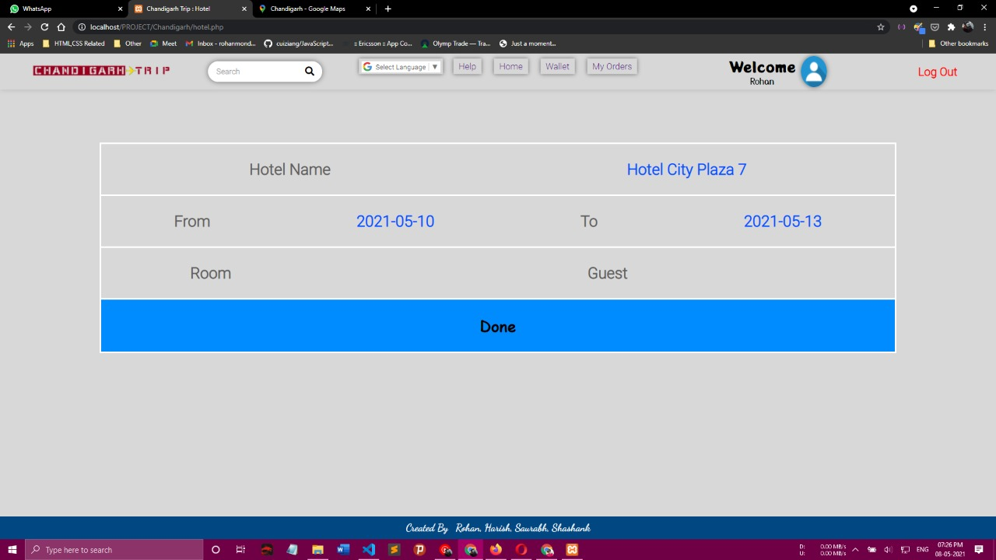

**OutPut: -** Booking Detail

**Major Issue: -** Database Data retrieve , Sign Up

**Solution: -** Our Team Tested Software and found Three Major issues and Check Module One by one And solve all three issues And retesting Software.

**Medium: -** Booking Confirmation

**Solution:-** Our Team Tested Software and found one medium issue and Check Module And There is issue we found is that the confirmation page is not showing and our team changes the code and solve the issues And retesting Software.

**Minor Issue:**-Menu item

**Solution: -** Our Team Tested Software and found one Minor issue and Check Module and had some changes and solve the issue And retesting Software.

# Limitations and Future Development

There are some limitations for the current system to which solutions can be provided as a future development:

* + 1. The system is not configured for multi- users at this time. The concept of transaction can be used to achieve this.
    2. The Website is not accessible to everyone. It can be deployed on a Own server so that everybody cannot use this site till now.
    3. Credit Card validation is not done. Third party proprietary software can be used for validation check.

As for other future developments, the following can be done:

* + - 1. The Administrator of the web site can be given more functionality, like looking at a specific customer’s profile, the hotels, flights and food that have to be reordered, etc.
      2. Multiple bookings can be allowed.

# 11.0. Input & Output Snapshots

**Home page**

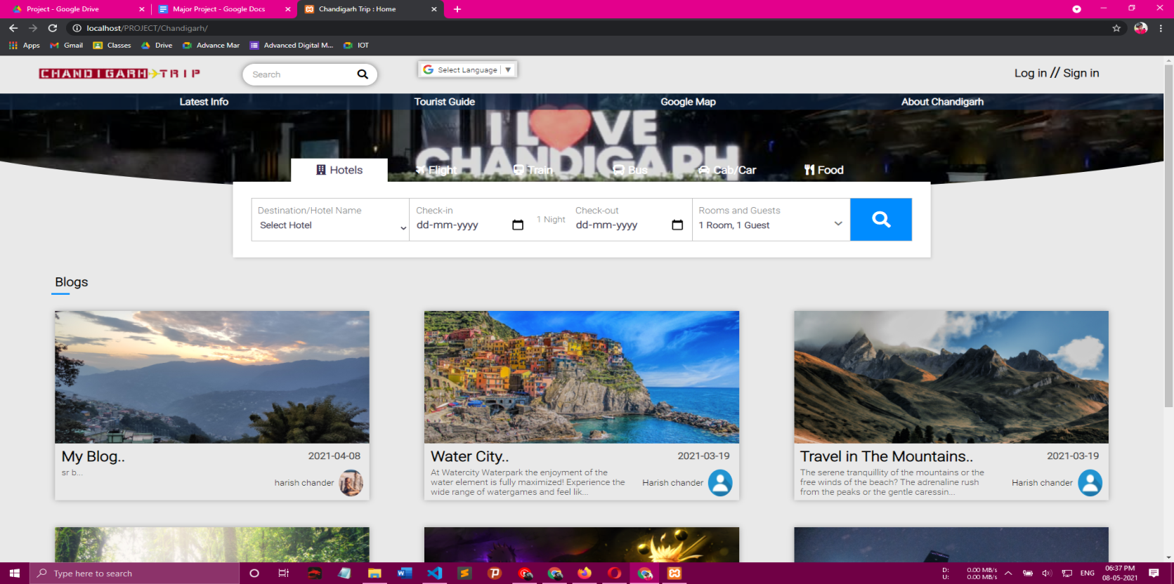

**Log-in Page**



**Sign-in Page**

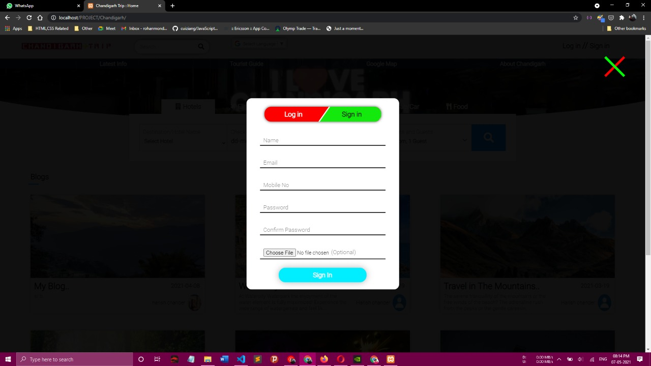

**Logo**



**Booking page**

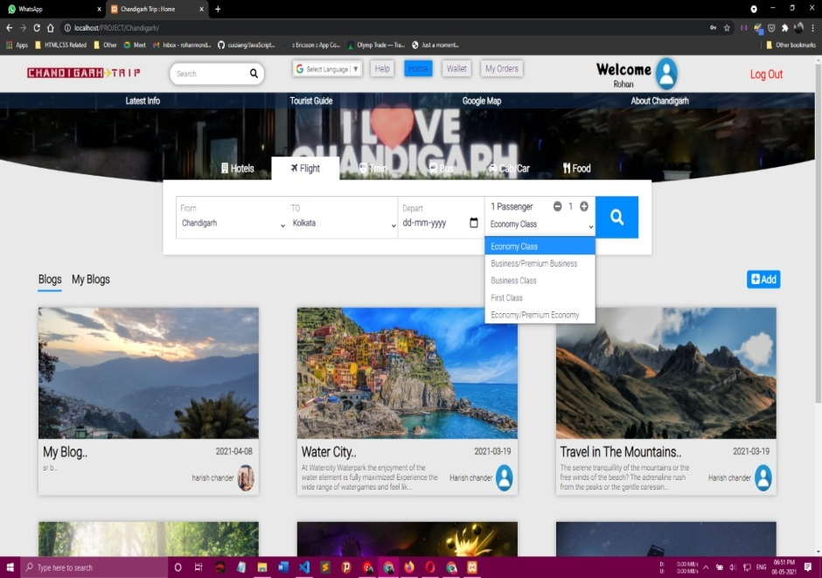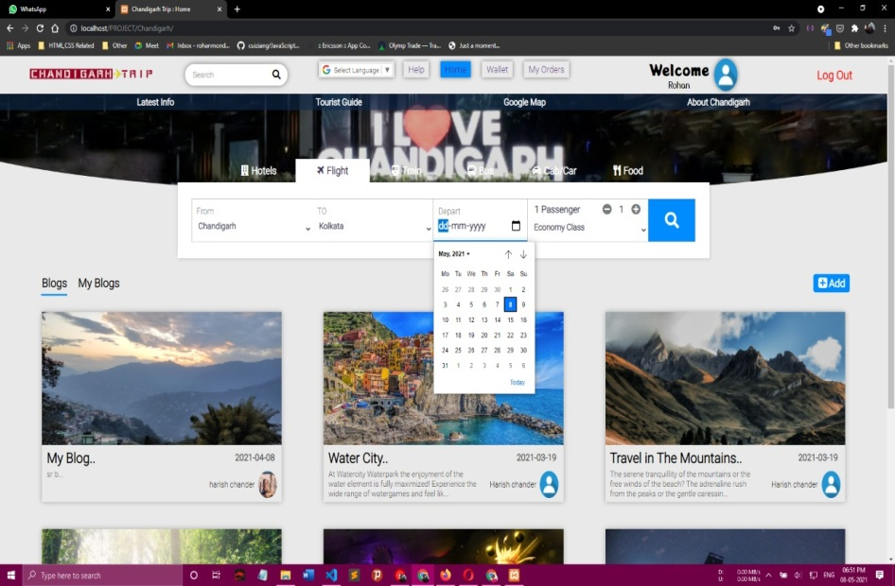

**Add Blogs**

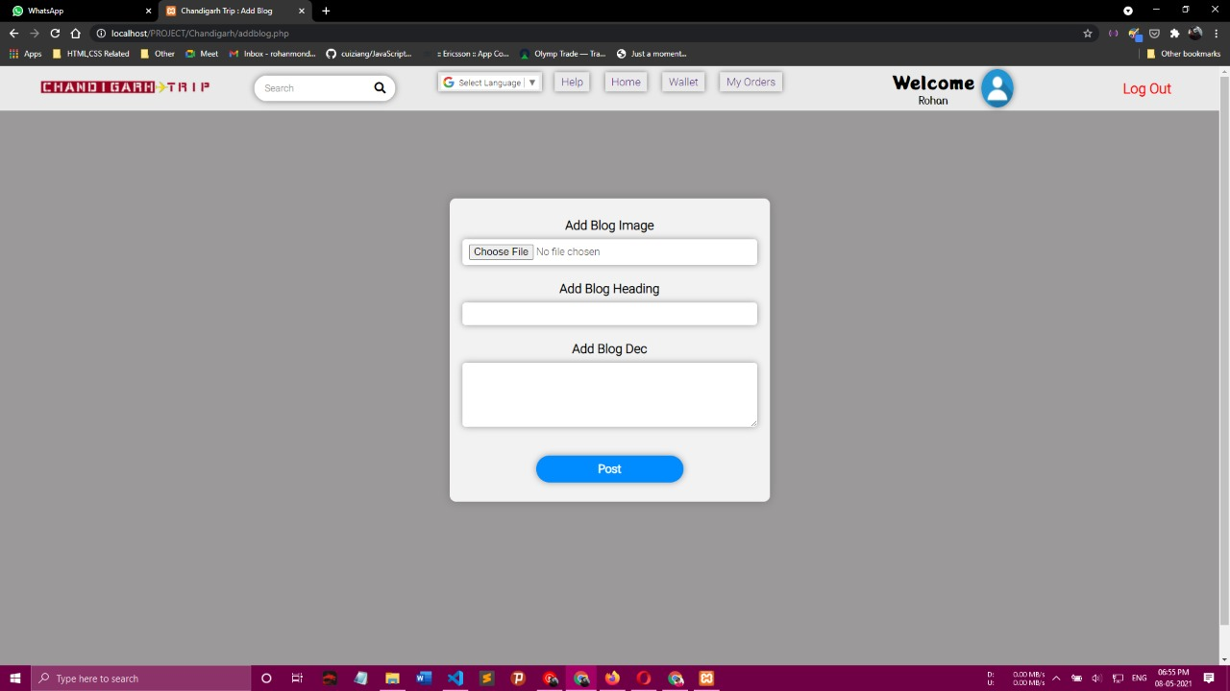

**Blogs**

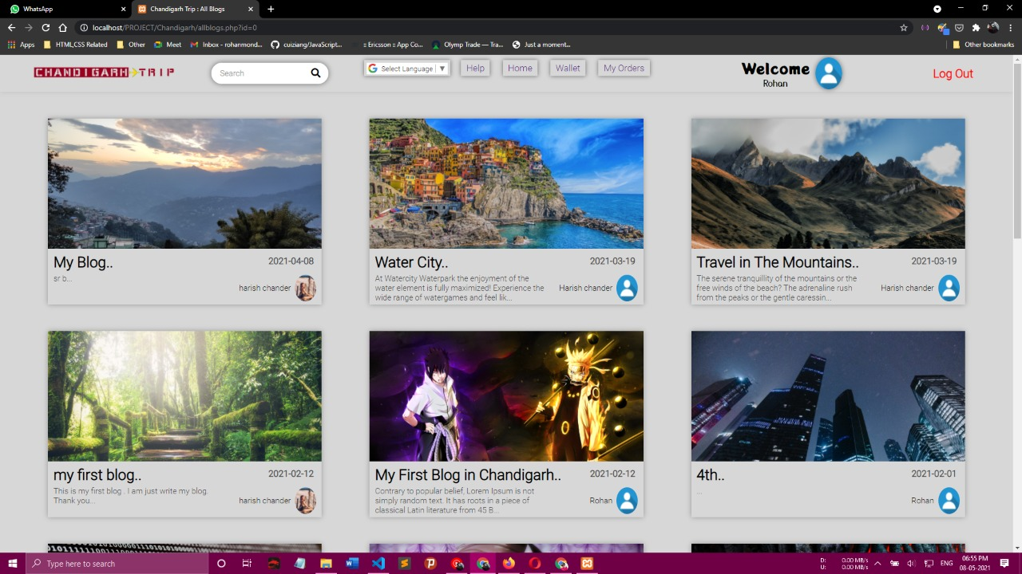

**Tourist Guide And Information About Chandigarh**

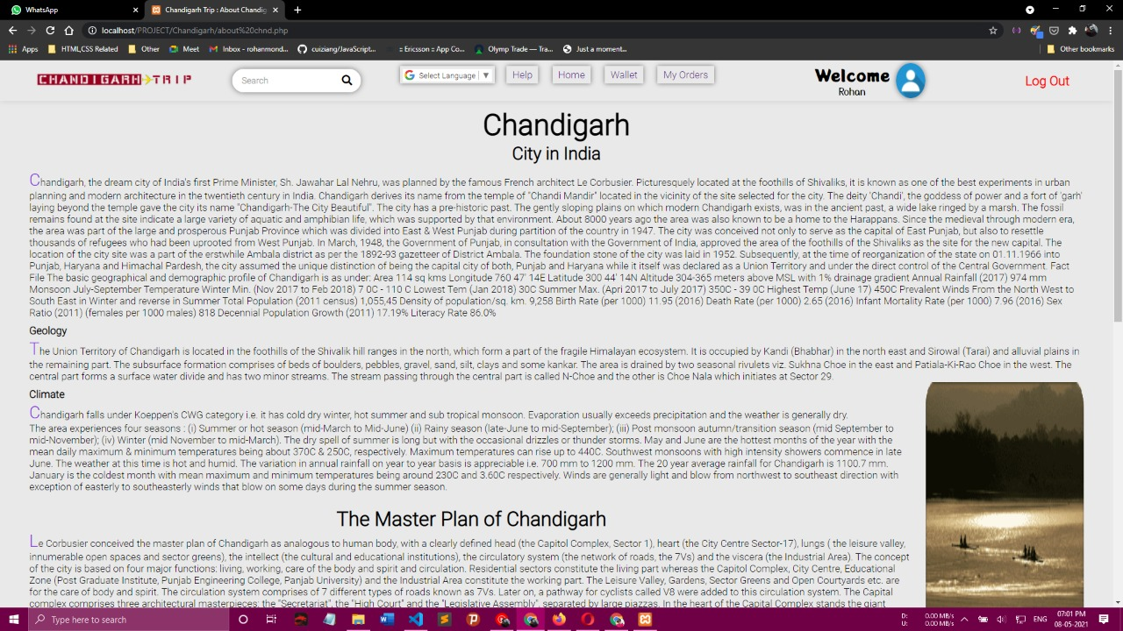

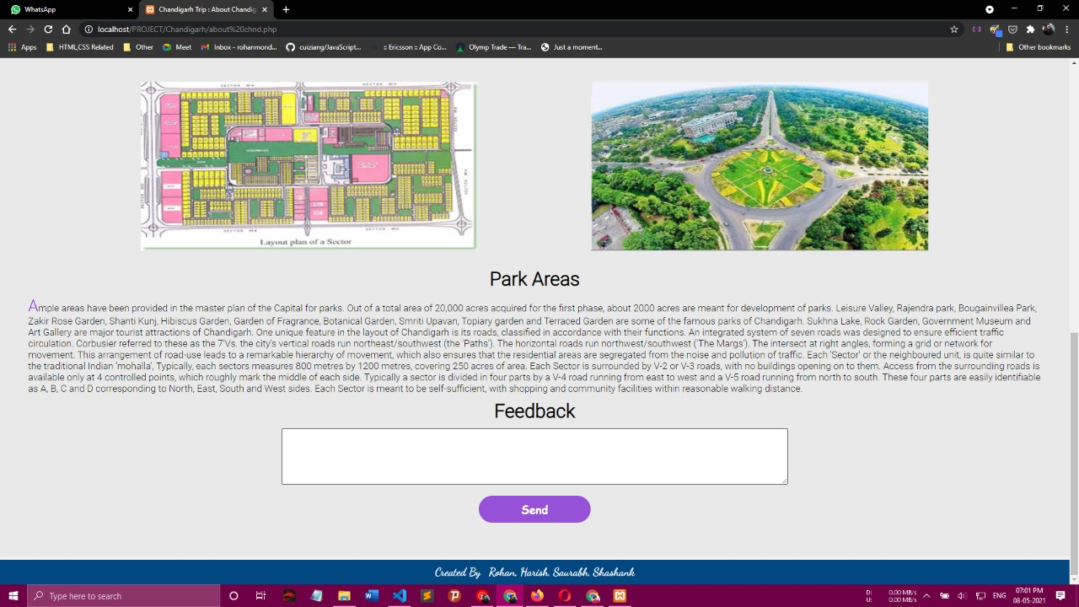

**Multiple Languages Support**

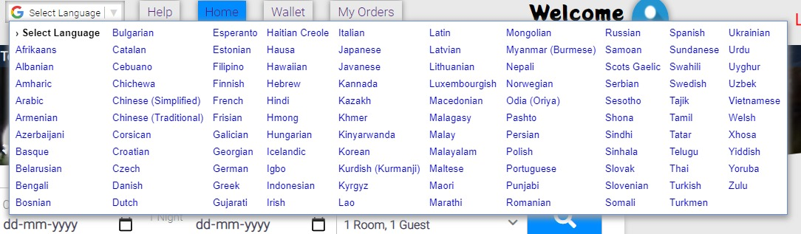

* Here we are using Google's API.

**Google Map**

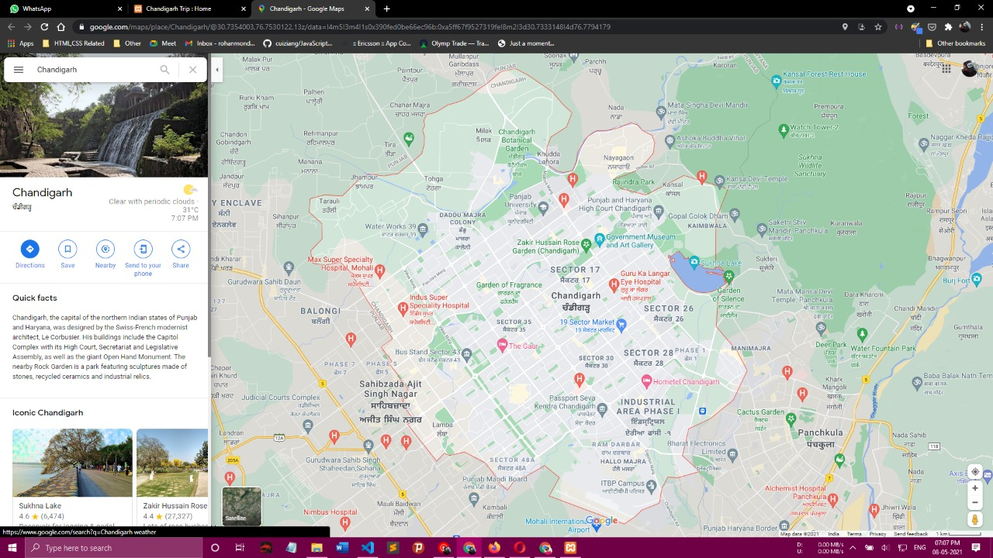

* This Map will work with the help of Google API.

**Wallet and add Money**

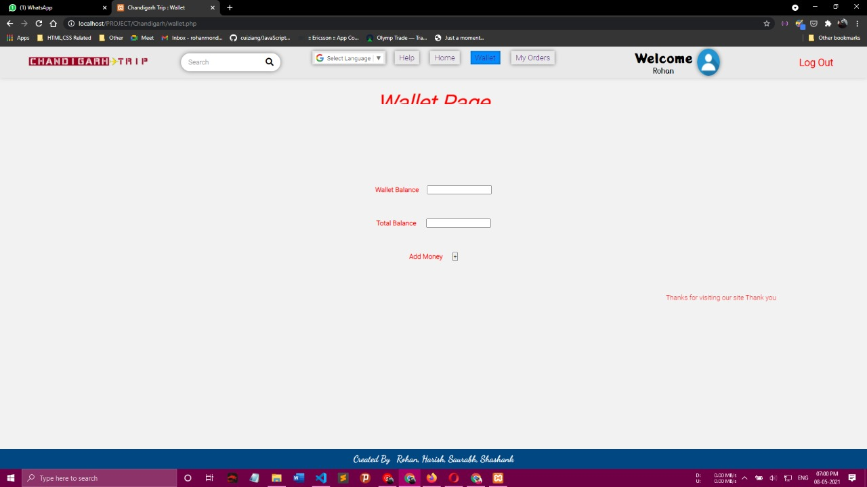

**Successfully Registered**



**Booking**

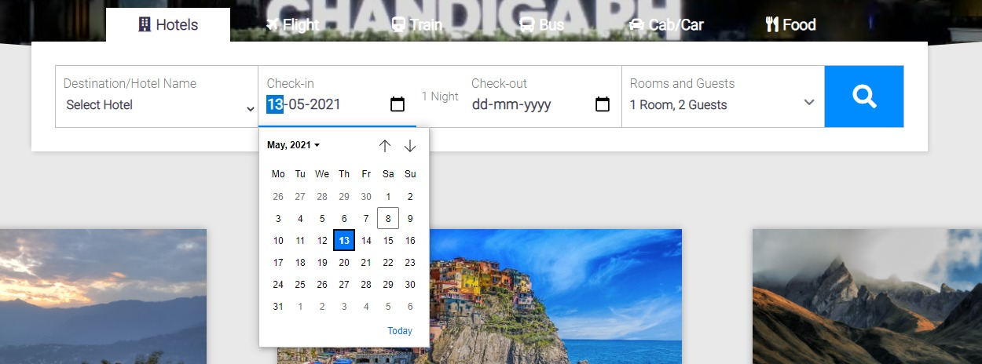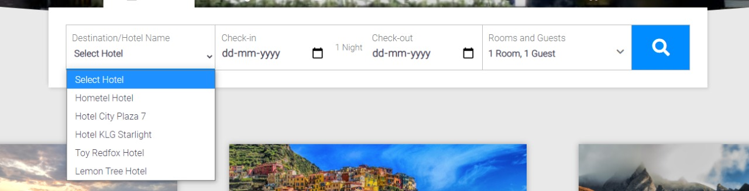

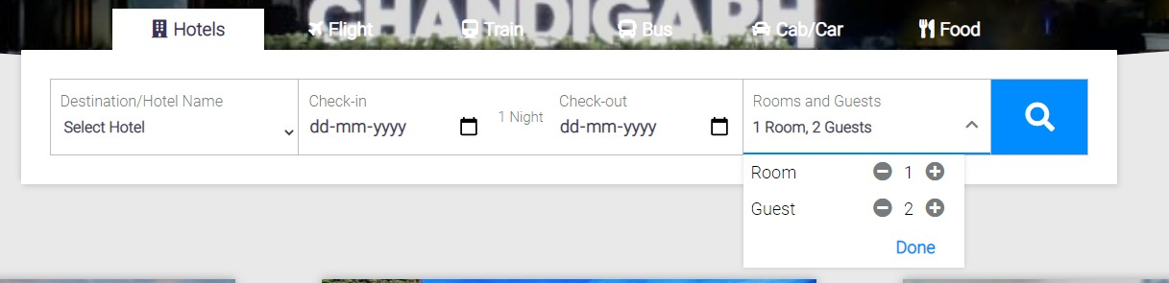

**Loge-in and Log-out**



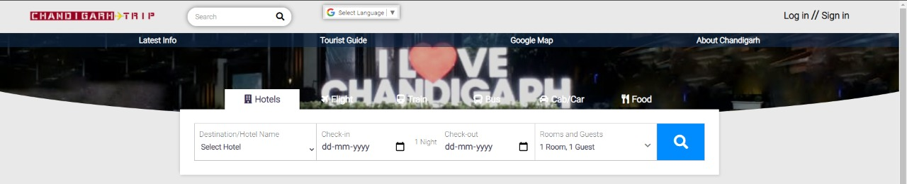

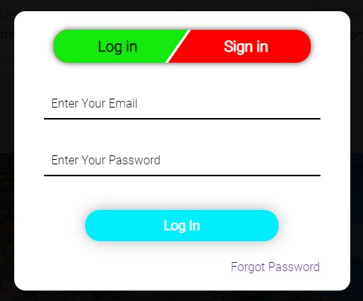

**Feedback**



**Contact Us**

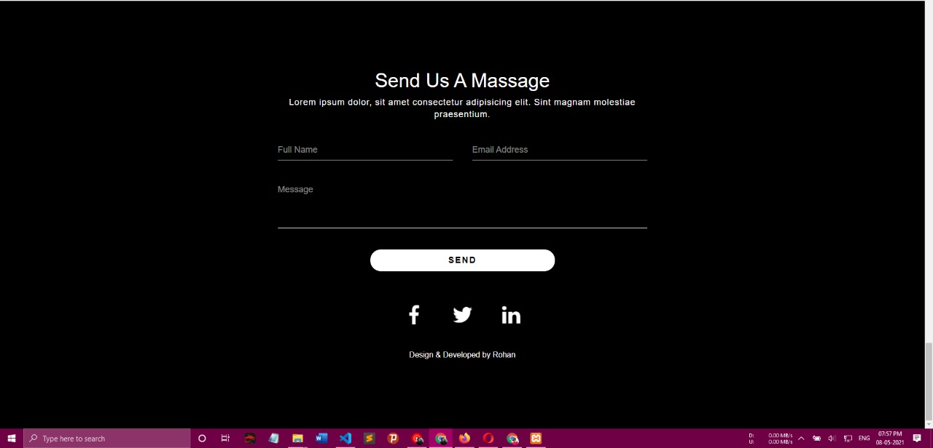

# 13.0. Conclusion

Consumer behavior towards tourism depends on various factors and the main aim of this project is focused on this aspect and a detailed evaluation is done against this key aspect to understand the consumer behavior towards choosing India as the tourism destination. The required primary source of information is gathered from the direct interviews conducted with the tourists in Chandigarh and an empirical investigation is done towards their perception in making the key decisions while deciding upon the tourism destination. Almost 100 respondents are interviewed in this context and quantitative research methodology is selected to proceed with the research and the key findings from the interview process are also given in this research. An option based interview questionnaire is prepared in this context and escalated among the respondents involved in the research and the information gathered from them is used to conduct the research and conclude their perception towards Indian tourism and also to understand the key factors that affect their behavior while choosing India as their destination. The key factors that were considered to evaluate this research are the financial conditions, safety, source of advertisement, exchange rate, demographic attributes like age, sex and occupation, reputation of India, facilities in terms of accommodation and living conditions, ticket price, distance to the destination and purpose of visit and the corresponding findings are analyzed using the statistical analysis and Microsoft Excel is used as the required tool in this context and the key findings are as given below.

From the findings it is clear that, most of the tourists prefer India as the tourism destination to spend their holiday time and among these people think twice to choose India as the tourism place in terms of their financial position. Few aspects like tickets and total expenses to spend in India are considered while making their decision and from the findings it is clear that almost half of the respondents interviewed consider these aspects before visiting India. When the tourists are asked regarding the distance consideration, most of them replied that distance is not at all a factor when they are planning for a holiday trip and they always look for the hospitality and surviving conditions in India. Reputation of the country also plays an important role against the consumer behavior and it is proved from the findings as most of the tourists prefer India as the level of reputation in attracting the tourists is on the top level and also the accommodation provided in India is at corporate level. Cultural attraction also plays a vital role in attracting the tourists from different countries and from the findings it is clear that all most all the respondents interviewed prefer India as the culture and the activities at the tourism spots are excellent in nature and thus it can be understood that culture plays an important role in estimating the consumer behavior towards tourism. Apart from these core aspects, the key issues like security and safety also plays an important role in estimating the consumer behavior towards tourism and from the analysis of the findings it is clear that, most of the tourists think a while about their safety as India is prone to frequent terrorist attacks and thus in aspects, India is losing ample customers against their tourism. Advertising the key media that were considered by the consumers in choosing the tourism destination and from the findings it is clear that, most of the customers are attracted towards India via the media like newspapers and TV advertisements. From the overall analysis it is clear that consumer behavior against the tourism is mainly affected by the factors like safety, cost of trip and the cultural attractions at the tourism destination and when these aspects are related to India, it has provided the maximum to the tourists and need to improve and refine the policies against safety measures for the tourists in future.

**Future Scope**

* Our Future Scope/Goal is to make this website more easy to use.
* We will Give Best offers.
* Best guides.
* Best and safe hotels.
* We will Provide our own Customer Care Center in Chandigarh.
* We will also provide jobs.
* We will also create an apk for IOS and Android.

**References**

* www.w3schools.com
* www.geeksforgeeks.org
* [www.similarweb.com](http://www.similarweb.com)
* **Our Facility members**

